A Long Walk to Water Pre-Reading Stations
Name:  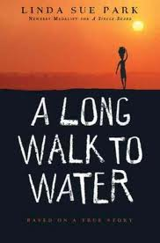 | Water Footprint  Explore National Geographic’s water conservation Web site.  Visit each tab under “Freshwater:” Freshwater Stories, Why it Matters, Get Engaged, and Change the Course. Record one observation from each on the other side of this paper. | Bucket Carry  Carry the bucket up and down the 8th grade hallway five times. Then reflect what it would be like to do it not for a few minutes – but for 15 hours a day. This is the reality for millions of Ethiopians. Write your reflection on the other side of this paper.
Lost Boys Map  With a partner, complete the instructions for the map activity. MAKE SURE YOU READ ALL OF THE INSTRUCTIONS BEFORE COMPLETEING EACH STEP. | Anticipation Guide  Complete an anticipation guide on the table. Staple it to this paper. | Evaluation  Circle the number that shows how much you enjoyed the stations. Describe why you feel this way.  1 2 3 4

Water Footprint | Bucket Carry

