NAME: ___________________________________

Microsoft Word Tutorial
Step One
Open a blank MS Word document and save it on your H drive in your Research Folder under the name, MS Word Practice. (Remember, there are instructions in your Research Skills Resources packet to help you.)

Step Two
Type the text below into your document. NOTE – there are some errors in text on purpose. Type what you see below EXACTLY how it appears. When you are done typing, don’t forget to save.
Microsoft Word Practice
by (insert your name)
Today in Langag Arts class we is practicing our Microsoft Word Skills. We are learning valuable skills, such as how to double-space select the correct font and insert page numbers. To help us with our skills.

Step Three

Select all the text using the cursor and your mouse.
In the Paragraph section of the tool bar, click the double-space button and choose 2. Save.
Your text should now look like this …
Microsoft Word Practice
by (insert your name)
Today in Langag Arts class we is practicing our Microsoft Word Skills. We are learning valuable skills, such as how to double-space select the correct font and insert page numbers. To help us with our skills.
Step Four
Select all the text again using your cursor and your mouse. In the Font section on the tool bar, choose Times New Roman, size 14. Save.

Your text should now look like this …

Microsoft Word Practice
by (insert your name)
Today in Langag Arts class we is practicing our Microsoft Word Skills. We are learning valuable skills, such as how to double-space select the correct font and insert page numbers. To help us with our skills.

Step Five
Select the title – Microsoft Word Practice – and your name using the cursor and your mouse.

In the Paragraph section on the tool bar, click the center alignment button.
Save.

Now, your text should look like this …

Microsoft Word Practice
by (insert your name)
Today in Langag Arts class we is practicing our Microsoft Word Skills. We are learning valuable skills, such as how to double-space select the correct font and insert page numbers. To help us with our skills.

Step Six
Choose Insert from the tabs above the tool bar.
Click Page Number, Bottom of Page, and then Plain Number 1. Then click Close Header and Footer. A small #1 should now be at the bottom of your page. Save.
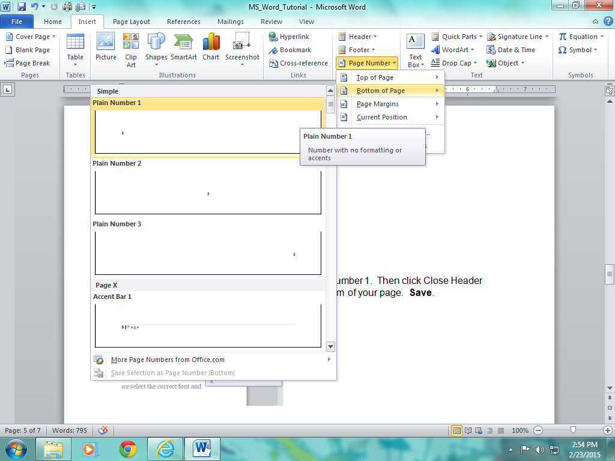
Step Seven
There are three words or phrases underlined in green in the text. This means these sentences possibly have grammatical errors.

First, right-click on the word “by.” At the top of the window, you are given three choices: By (a replacement suggestion), Ignore Once (which will leave the word or phrase the same), and Grammar (which will explain why the word or phrase might be wrong). In this case, it is correct to use a lowercase b, so choose Ignore Once. Save.
Now, right-click on the word “is.” Again, you have three choices: Are (a replacement suggestion), Ignore Once (which will leave the word or phrase the same), and Grammar (which will explain why the word or phrase might be wrong). Read the sentence using the replacement word “are” instead. Does that sound better? Click on “are” to replace “is.” Save.

Next, right-click on the phrase “To help us with our skills.” This time you have only two choices: Ignore Once (which will leave the word or phrase the same) and Grammar (which will explain why the word or phrase might be wrong). However, notice at the top it does tell you that this is a Fragment, or incomplete sentence. So, you don’t want to choose Ignore Once, because the sentence is grammatically incorrect. Pick Grammar, then Explain and see if the information you are given can help you revise the sentence. Save.

Last, read the text carefully one more time. Did the computer catch all the possible grammar mistakes??? (Hint: there is some missing punctuation.) Save.

Step Eight
There is one word underlined in red in the text. This means this word is misspelled.

Right-click on “Langag.” You will see that the computer offers you lots of possible choices for the correct spelling of the word it thinks you are trying to use.

Don’t just pick the first suggestion! Find the correct word on the list and click it to replace the misspelled one. Save.

Congratulations!!! You have completed the 8th Grade Language Arts Microsoft Word Tutorial. Your text should now look (something) like this …

Microsoft Word Practice
by (insert your name)
Today in Language Arts class we are practicing our Microsoft Word Skills. We are learning valuable skills, such as how to double-space, select the correct font and insert page numbers. This tutorial will help us with our skills.

