GROUP CHARACTERIZATION SKIT RUBRIC

Attribute | Encore  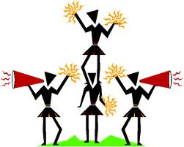 | Standing Ovation | Thunderous Applause  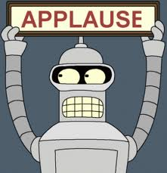 | Polite Clapping
Content | Every character type was portrayed in the skit at least once  AND  Some character traits were portrayed more than once.  AND  It was obvious to the audience which character type was being acted out.  AND  Skit has a title. | Every character type was portrayed in the skit at least once.  AND  It was obvious to the audience which character type was being acted out.  AND  Skit has a title. | Every character type was portrayed in the skit at least once.  OR  It was obvious to the audience which character type was being acted out.  AND  Skit has a title. | Every character type was not portrayed in the skit at least once.  AND  It was not obvious to the audience which character type was being acted out.  AND  Skit has a title.
Clear Characterization | The skit revealed interactions between all character types in a way that made the concept of characterization clear to the audience.  AND  The skit was enhanced by the use of props or scenery. | The skit revealed interactions between all character types in a way that made the concept of characterization clear to the audience. | The skit revealed interactions between all character types but was unable to clearly portray these character types to the audience. | The skit revealed interactions between many character types, though not all were represented  AND  The skit did not clearly portray the character types to the audience.
Delivery | All characters had speaking roles that clearly revealed the aspect of characterization they represented.  AND  The characters spoke audibly and with expression to make the skit interactions understandable. | All students had speaking roles that clearly revealed the aspect of characterization they represented.  AND  The students spoke audibly to make the skit interactions understandable. | All students had speaking roles that revealed the aspect of characterization they represented.  OR  The characters spoke audibly to make the skit interactions understandable. | All students did not have speaking roles that revealed the aspect of characterization they represented.  AND  The students did not speak audibly to make the skit interactions understandable.

I was able to identify the following types of characters during the skit.

Protagonist
Antagonist
Dynamic Character
Static Character

Warm Comments for the Presenters:

1.

2.

3.

Cool Comments for the Presenters:

1.

2.

3.

Name of Skit: __________________________________________________________________________

Name of Reviewer: __________________________________________________________________________

